**Integration of RTC and DOORS**

<https://jazz.net/library/LearnItem.jsp?href=content/articles/rtc/3.0/configuring-doors-and-rtc-to-integrate/index.html>

<https://www.ibm.com/developerworks/rational/library/integrate-rational-doors-and-rational-team-concert-change-management/integrate-rational-doors-and-rational-team-concert-change-management-pdf.pdf>

Build basis: Rational DOORS 9.6.1.0, Rational DOORS Web Access 9.6.1.0, and Rational Team Concert RTC 5.0.2(Eclipse JUNO) running on windows.

RTC can be used with a number of browsers. The integration is supported only with Internet Explorer and Firefox, and to make it run on Firefox you need to use the **IETab2** plug-in to emulate Internet Explorer. This is because the Rational DOORS Web Access Change Details view needs ActiveX and the **Change Details** window cannot be rendered fully in Firefox without the plug-in.

You can configure Rational® DOORS® and Rational Team Concert™ (RTC) to integrate with one another by using Open Services for Lifecycle Collaboration (OSLC), an [open standard](http://open-services.net/) that IBM is developing in co-operation with business partners and customers. You use Rational DOORS to manage your requirements, and RTC to put your requirements under change control, preventing uncontrolled changes to your requirement set. Strict control of requirements is mandatory under many quality systems, and is needed if you are to keep track of the state of your requirements at any point in your product lifecycle.

After you have set up the two applications to communicate with one another, you can set up workflows in RTC and configuration templates in Rational DOORS with as much flexibility as you want. In this example, you will define a Requirements Change Request workflow that is based on the Scrum process in RTC. You will then define a work item type, and map the work item type to a Change Management type in Rational DOORS. Finally, you will define a configuration template in Rational DOORS and set up module configuration.

As with many configuration tasks in Rational DOORS and RTC, it is essential that you plan your integration. You cannot set up a change control system "as you go". You must know in advance what types of work items you will want to use, whether you want to have more than one workflow, how you want to control your change requests, and so on.

**Before you start, you need this software and setup:**

1. Rational DOORS server and client installed.

2. Rational DOORS Web Access installed and configured with the DOORS server.

3. Rational Team Concert installed.

4. Rational® Jazz™ Team Server set up in Rational Team Concert.

**Create a repository connection**

1. Open the Rational Team Concert client.

2. Find and run the eclipse.exe file: C:\Program File\IBM\jazz\client\eclipse\eclipse.exe

3. Select the workspace.

4. Click the Create Repository Connection link. The next view will be the Create a Jazz Repository Connection dialog window shown in the Figure.

Use the Rational Team Concert client to create a Jazz repository connection

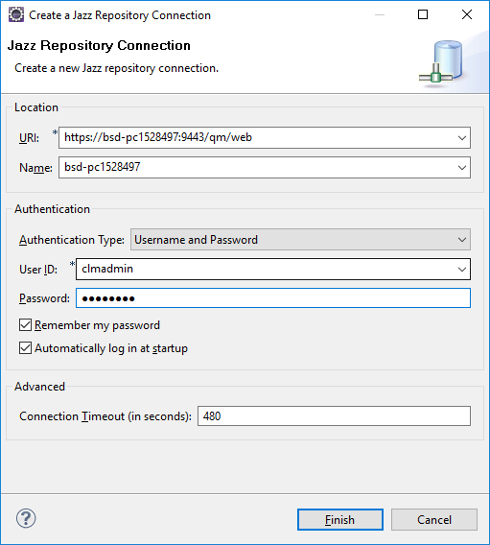

5. Enter the Rational Team Concert server URL, for example: <https://bsd-pc1528497:9443/ccm>

**Note**: The Name field details are automatically populated to localhost.

6. Enter the User ID and password.

7. Click Finish

**Create a project Area**

Open the **Create Project Area** page:

1. In the **Team Artifacts** view of the Work Items perspective, click **Project areas**.
2. Select **Create Project Area**.
3. Create the project area.
   1. Enter a project name and select **Scrum**.
   2. Add a user to the **Members** and **Administration** sections.
   3. Click **Save**.
4. Configure the new project.
   1. Click **Project areas**, and double-click the new project.
   2. Click the **Permissions** tab.
   3. Select **Project Configuration**, and select all of the permitted actions for the team member.
   4. Select **Team Configuration**, and select all of the permitted actions for the team member.
   5. Click **Save**.

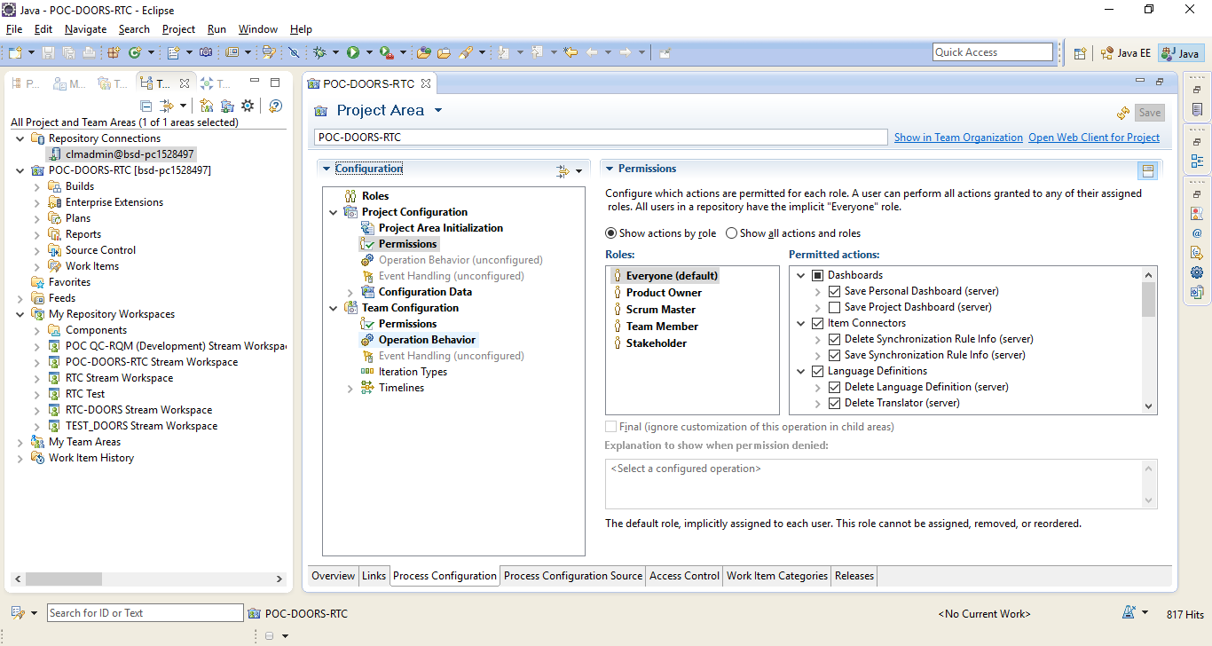

**Set up a new RCR workflow:**

Can be done in RTC Client or Web Client.

1. In the new project, click the **Work Items** tab, and select **Workflows**.
2. Create a workflow called **RCR Workflow**.
3. Add or edit states. Make entries for **Created**, **Assigned**, **Review**, **Approved**, **Applied**, and **Rejected**:
   1. In the **States** section, click **Add**.
   2. Enter a name and brief description for the state.
   3. Select a group that is appropriate for each state. For **Created**, **Review**, **Approved**, and **Rejected**, select the **Open** group. For **Assigned**, select the **InProgress** group. For **Applied**, select the **Closed** group.
   4. The process templates include a set of icons. Select an icon, or click **Add Icons** and select your own graphics file to use as the icon for the state.
   5. Click **OK**.

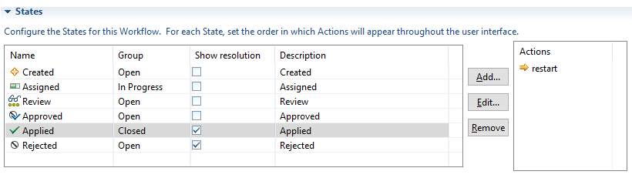

1. Add or edit actions. Make entries for **apply**, **approve**, **assign**, **reject**, **restart**, **send to review**, and **start**:
   1. In the **Actions** section, and click **Add**.
   2. Enter a name and brief description for the action.
   3. Select a target state that is appropriate for each state. For **apply**, select **Applied**, for **approve**, select **Approved**, for **assign**, select **Assigned**, for **reject**, select **Rejected**, for **restart**, select **Created**, for **send to review**, select **Review**, and for **start**, select **Created**.
   4. The process templates include a set of icons. Select an icon, or click **Add Icons** and select your own graphics file to use as the icon for the state.
   5. Click **OK**.

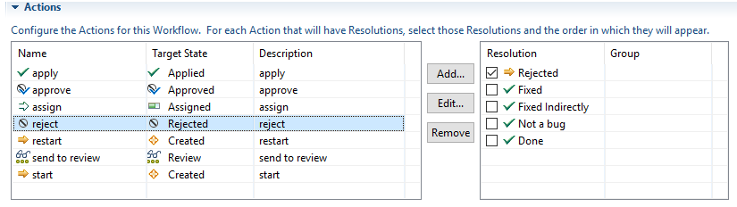

1. In the **Transitions** section, the state transition model is displayed. The row headings contain the **From** state, and the column headings contain the **Target** state. Add actions for the states:

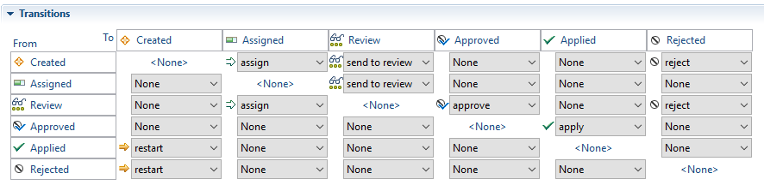

1. In the **Workflow** section, set the main workflow actions:
   1. In the **Start** action field, select **start**.
   2. In the **Resolve** action field, select **resolve**.
   3. In the **Reopen** field, select **reopen**.
2. Add a resolution:
   1. In the **Resolutions** section, click **Add**.
   2. Enter a name and brief description for the manner in which a work item can be resolved. For example, you might define resolutions such as **Fixed**, **Fixed indirectly**, and **Not a bug**.
   3. Select or add an icon for the resolution, then click **OK**.

To define all resolutions in the workflow, repeat these steps.

1. In the **Actions** section, for each action that can be resolved, select those resolutions and the order in which they are displayed in the work item editor and other places throughout the user interface. To set the order of the resolutions, click **Move Up** and **Move Down** in the **Resolution** table.
2. In the **States** section, for each state, set the order in which to display the available actions in the work item editor and other places throughout the user interface. Select a state. To set the order of the actions, click **Move Up** and **Move Down** in the **Actions** table.
3. Click **Save**.
4. To associate a type category with the new workflow:
   1. In the **Configuration** menu, click **Types and Attributes**.
   2. Select a type that is associated with the type category for which to designate the new workflow.
   3. Select the new workflow, and then click **Save**.

If you change the workflow association for a type category, all work item types that are associated with that category also adopt the new workflow

You now need to define a work item type that uses this workflow

**Define a work item type called Requirement Change Request:**

1. In the project, open the **Types and Attributes** page:
   1. In the **Team Artifacts** view of the **Work Items** perspective, right-click the project area and select **Open**.
   2. Click the **Process Configuration** tab.
   3. Expand **Project Configuration > Configuration Data > Work Items**, and then click **Types and Attributes**.
2. In the **Work Item Types** section, click **Add**.
3. In the **Add type** window:
   1. In **Name**, enter **Requirement Change Request**.
   2. Create a type category to associate the work item type with. Enter **demo.workitem.workitemType.rcr**.
   3. Click **OK** to create the new work item type, and open it in the **Types and Attributes** page.
4. Select an icon, and click **OK**.
5. Create an alias. Enter **rcr**.
6. Select an editor presentation that defines how the new work item type is displayed in each of the following editors:

* Work Item Editor: The default editor for creating and modifying work items. Select **demo.workitem.editor**.
* Inline Work Item Editor: The editor for inline work item modification. Select **com.ibm.team.workitem.web.inline.task**.
* Lightweight Work Item Creation Dialog: The editor for quickly creating work items. Select **com.ibm.team.workitem.lightweight.editor.section**.
* Plan Editor Preview: The editor for viewing and modifying work items inside a plan. Select **com.ibm.team.apt.planPreview.task**.

You can customize the editor presentations on the **Editor Presentations** page.

1. In **Workflow**, select **RCR Workflow**.
2. Click **Save**.

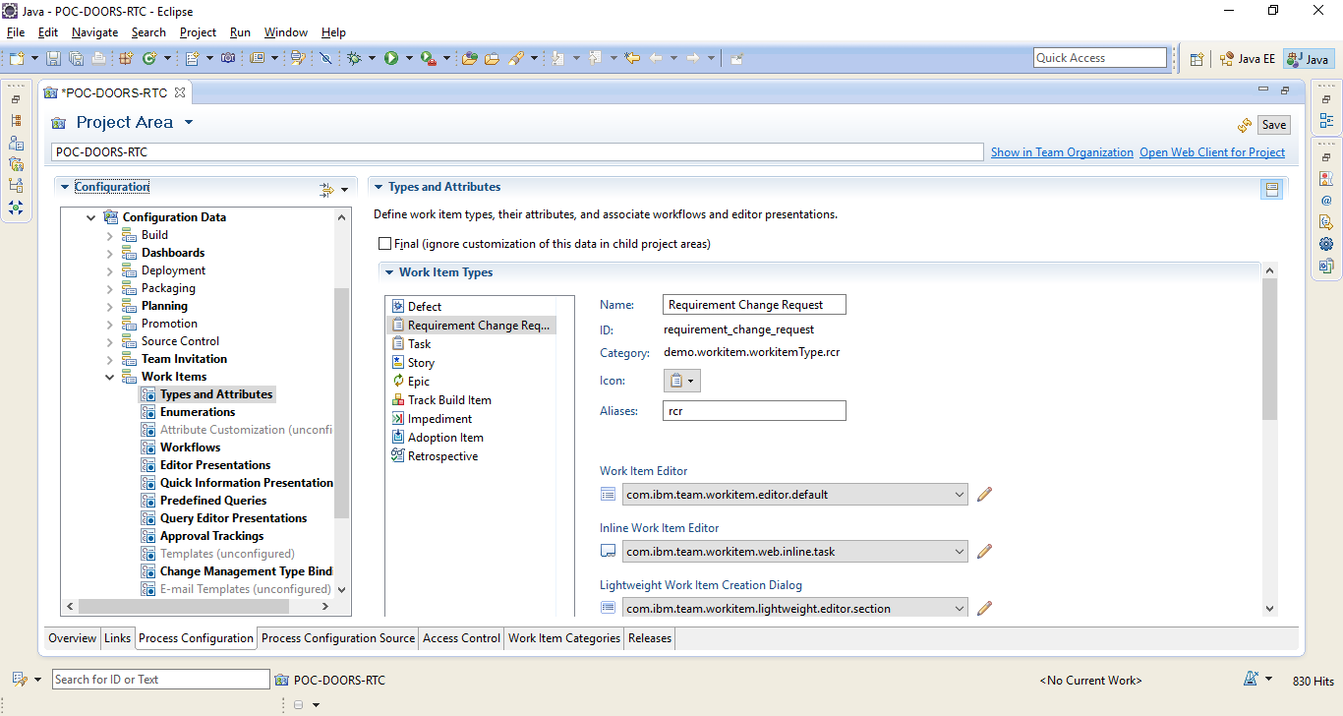

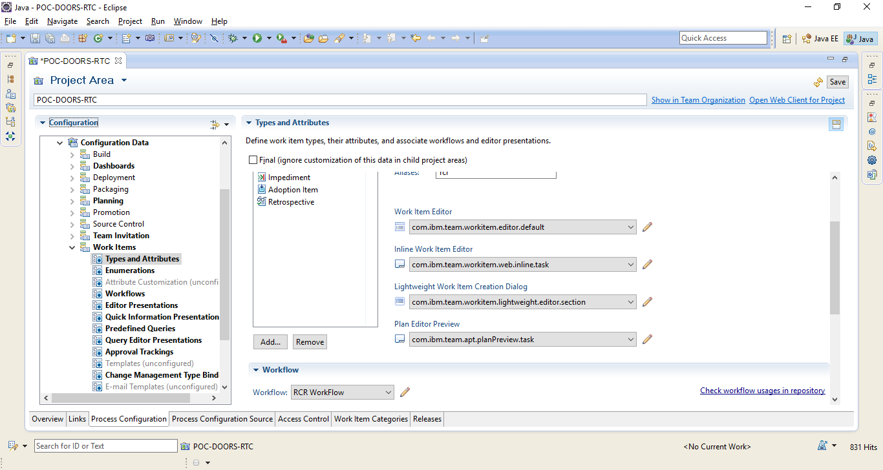

**Define the mapping between the change management type and work item type**

The next step is to define the mapping between the change management type and work item type. The type bindings define the type of work items that are made available in OSLC integrations.

**Configure the Change Management Type binding in RTC:**

1. In the project, open the **Change Management Type Bindings** page:
   1. In the **Team Artifacts** view of the **Work Items** perspective, right-click the project area and select **Open**.
   2. Click the **Process Configuration** tab.
   3. Click **Project Configuration > Configuration Data > Work Items**, and then click **Change Management Type Bindings**.
2. In the **Defect** row, select **Defect**, and then select the state that indicates that this type is ready for testing. Select the state that indicates that this type has reached resolution.
3. In the **Implementation Request** row, select **Requirement Change Request**, and then select the state that indicates that this type is ready for testing.
4. In the **Quality Task** row, select **Task**.
5. In the **Requirement CR** row, select **Requirement Change Request**.
6. Click Save.

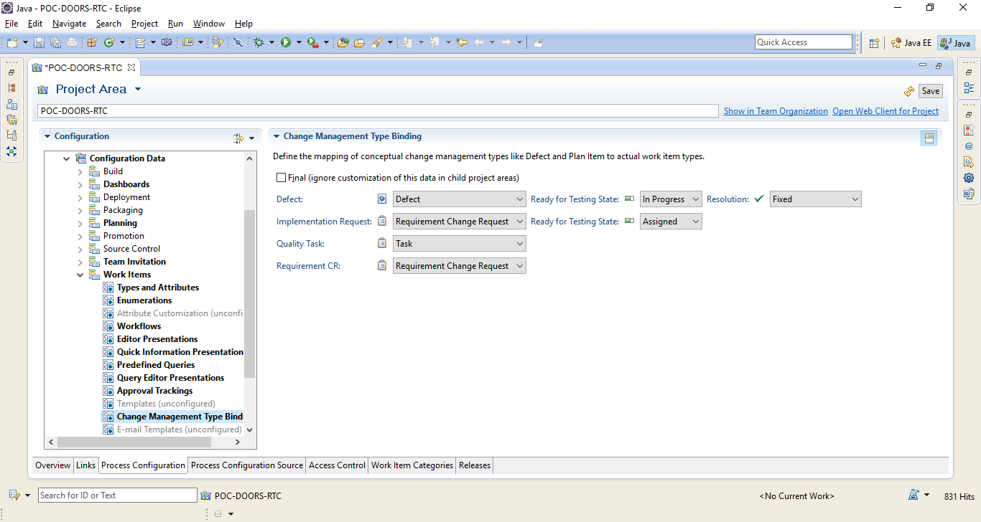

**Configure RTC and Rational DOORS to communicate with one another**

To allow the integration to work correctly, both RTC and the Rational DOORS database must be set up to communicate with one another.

**Before you begin**

Get yourself database manager powers or custom user powers to manage the database in Rational DOORS.

Make sure that Rational DOORS Web Access is running in **https** mode.

Make sure that you have logged in to Rational DOORS Web Access at least once since it was started.

**Set up RTC to allow the connection from Rational DOORS:**

1. Log in to RTC as an administrator.
2. Go to the **Application Administration** page for the RTC application, click **Application Administration > Application**, and then, in the **Communication** section in the navigation menu on the left, click **Consumers (Inbound)**.
3. Create a consumer entry for Rational DOORS. Enter a consumer name (for example, DOORS), enter a consumer secret, and then click **Register**. Make a note of the consumer secret. It is used later when you set up Rational DOORS.
4. Rational DOORS is now registered in RTC as a consumer. Navigate to the list of authorized keys, and make a note of the consumer key that has been automatically allocated. It is used later when you set up Rational DOORS.

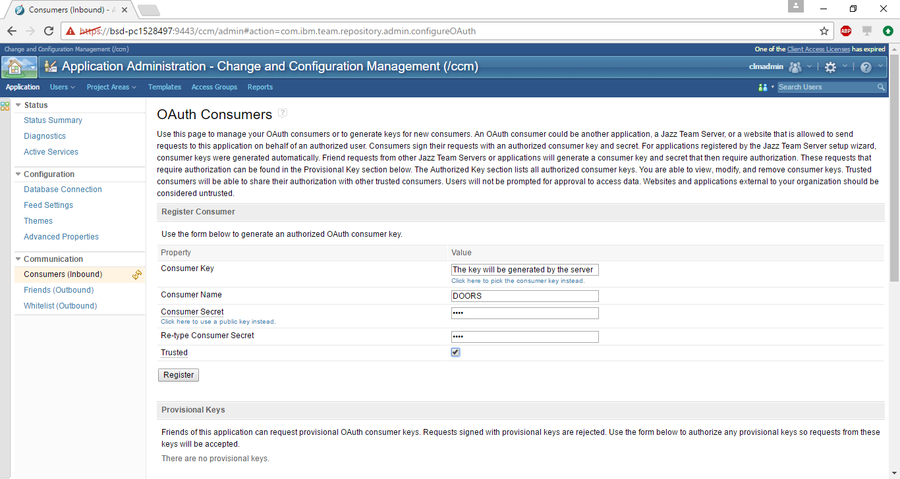

**Add Rational DOORS to RTC as a friend:**

1. In the navigation menu on the left, click **Friends (Outbound)**, and in the **Friends** pane, click **Add**.
2. Enter a name for the connection (for example, DOORS).
3. Enter the details for the Rational DOORS service. This service is hosted on Rational DOORS Web Access, and the default URL is **https://*hostname*:8443/dwa/public/rootservices**.
4. Enter an **OAuth secret** (for example, DOORS). Make a note of the OAuth secret. It is used later when you set up Rational DOORS.
5. Click **Create Friend**. A green confirmation message is displayed.
6. Click **Next**. Make a note of the Provisional key. It is used later when you configure Rational DOORS to access RTC.
7. Click **Finish**.

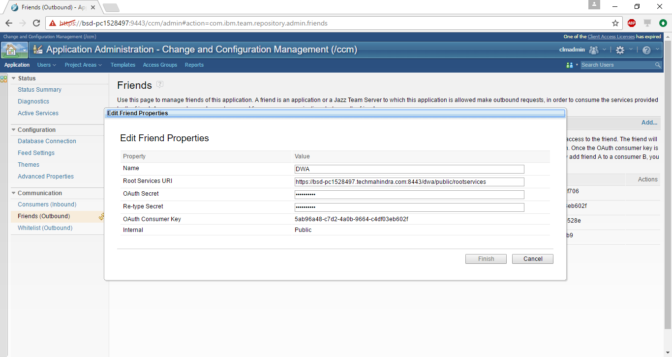

**Add Rational DOORS to the Whitelist in RTC:**

1. In the navigation page on the left, click **Whitelist (Outbound)**, and click **Add**.
2. In the **URL Whitelist** pane, enter the URL of the Rational DOORS database. The default URL is **https://*hostname*:8443/**.
3. Click **Add**. A green confirmation message is displayed.

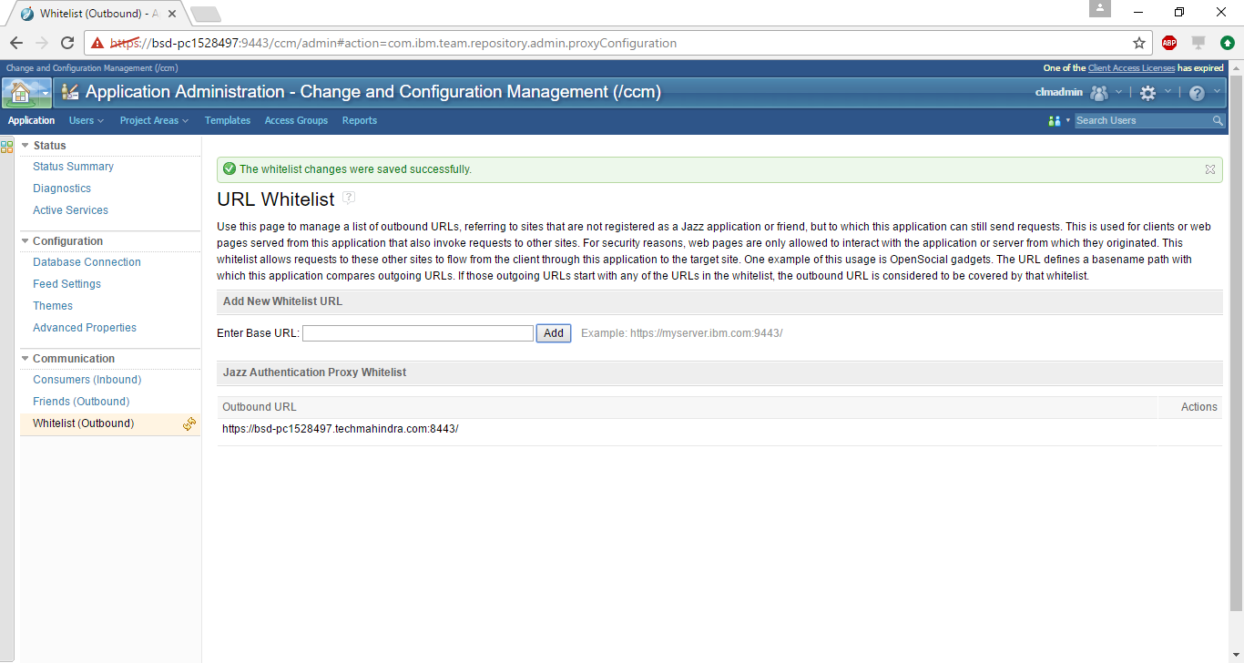

**Associate Rational DOORS with the project in RTC:**

You can create an association between a project area in RTC and a module in Rational DOORS. After you establish the association, you can link RTC artifacts, such as work items and plans, between the project area and objects in the module in Rational DOORS. There are two associations to create.

1. Open the project.
   1. In the **Team Artifacts** view of the Work Items perspective, click **Project areas**.
   2. Select the new project.
2. On the **Overview** page, scroll down to **Associations**, and click **Add**.
3. In **Application**, select the Rational DOORS connection. The name that is displayed is the name you entered in the Friends list.
4. The Rational DOORS Web Access login screen is displayed. Log in.
5. Go back to RTC.
6. In **Association**, select **Provides - Implementation Requests**.
7. In **Artifact Containers**, select the Rational DOORS module you want to work with.
8. Click **OK**, and select the next association.
9. In **Association**, select **Provides - Requirements Change Requests**.
10. In **Artifact Containers**, select the Rational DOORS module you want to work with.
11. Click **OK**, and then click **Save** to save the project.

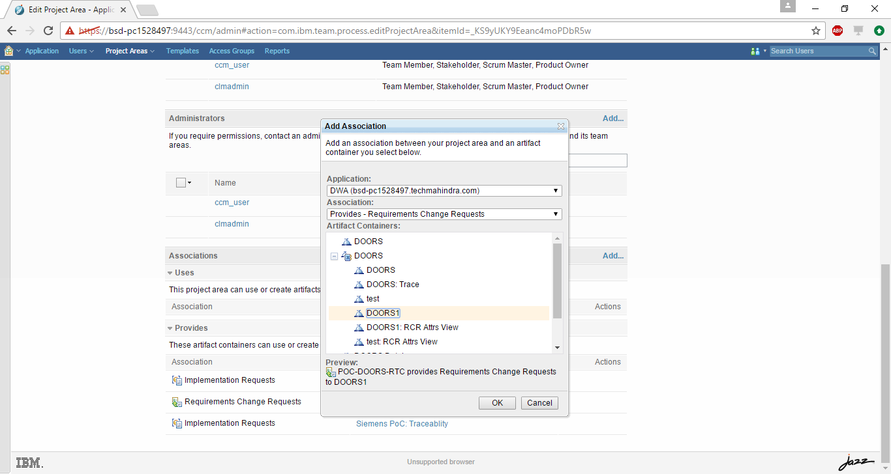

**Set up Rational DOORS to allow the connection from RTC:**

1. Log in to Rational DOORS as a database manager or a custom user who has the power to manage the database.
2. Right-click the database root, and select the **Remote Services** tab.
3. Add the RTC server to the Server List:
   1. Click **Add**, and enter a name for the connection (for example, RTC).
   2. Enter the URL for the root services of the RTC server.

[**https://*hostname*:*port*/ccm/rootservices**](https://hostname:port/ccm/rootservices).

Enter the consumer key and enter the consumer secret in **OAuth secret**. You made a note of these in **step 3** and **step 4** when you set up RTC.

* 1. Click **Register**. The server is added to the list.

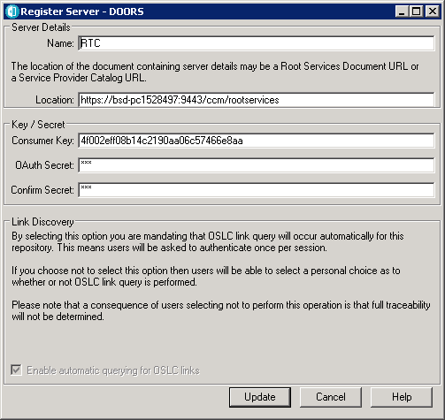

1. Add collaboration links from RTC projects to the Rational DOORS database:
   1. In the **Collaboration Links** pane, click **Add**.
   2. Select the server that you registered (**RTC**). If a security warning is displayed, click **Yes**.
   3. The login page to RTC is displayed. Log in.
   4. Select the project you want to access from Rational DOORS, and click **Add**.
   5. Go back to Rational DOORS. The project is displayed in the **Collaboration Links** pane of the **Remote Services** tab.

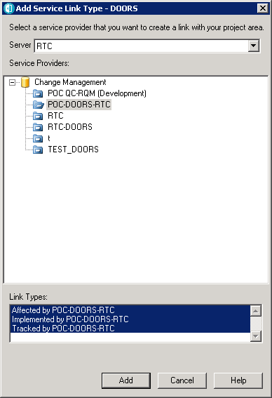

1. A Consumer Key and OAuth Secret should have been dynamically created when you added Rational DOORS as a friend to RTC earlier. If they have not been created, create a Consumer Key and OAuth Secret for the server:
   1. On the **Local Keys** tab of the Rational DOORS database properties, click **Add**.
   2. Enter the name of the connection (**RTC**).
   3. Enter the friends consumer key and in **OAuth secret**. You made a note of these when you added Rational DOORS to RTC as a friend.
   4. Click **Register**, and then click **OK** to close the database properties.

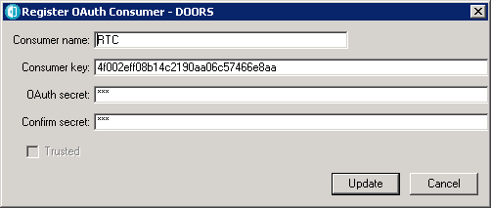

RTC and Rational DOORS are now configured to communicate with one another.

### **Define a configuration template in Rational DOORS**

The next step is to define a configuration template in Rational DOORS.

Defining a configuration template uses the Change Management for Rational DOORS functionality that is built into Rational DOORS. The configuration template specifies the project area in RTC, the workflow to use, and the states and actions in RTC that are to be used by Rational DOORS.

For information about Change Management for Rational DOORS, see the [Change Management for Rational DOORS](http://publib.boulder.ibm.com/infocenter/doorshlp/v9/topic/com.ibm.doors.install.doc/topics/doors_int_admin_user.pdf) manual.

**To define the configuration template:**

1. Open Rational DOORS.
2. Click **Change Management > Define Configuration Templates**. **Step 1** of the **Configuration Template wizard** is displayed.
3. Enter a name for the template.
4. Select **OAuth** as the authentication method.
5. Select your configured RTC project area, and click **Next**. The RTC login screen is displayed. If a **Security Alert** window is displayed, click **Yes**.

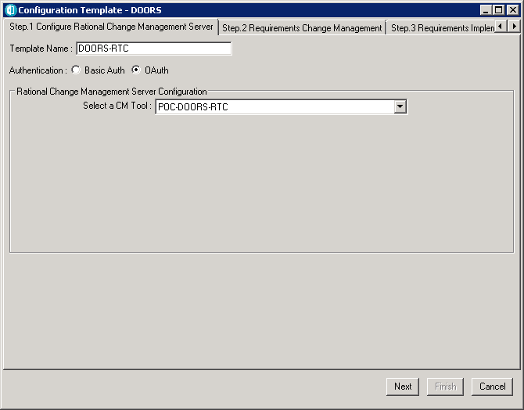

1. Log in to RTC. **Step 2** of the **Configuration Template wizard** in Rational DOORS is automatically displayed.
2. Map the RTC workflow states and actions to states and actions in the Requirements Change Management workflow.

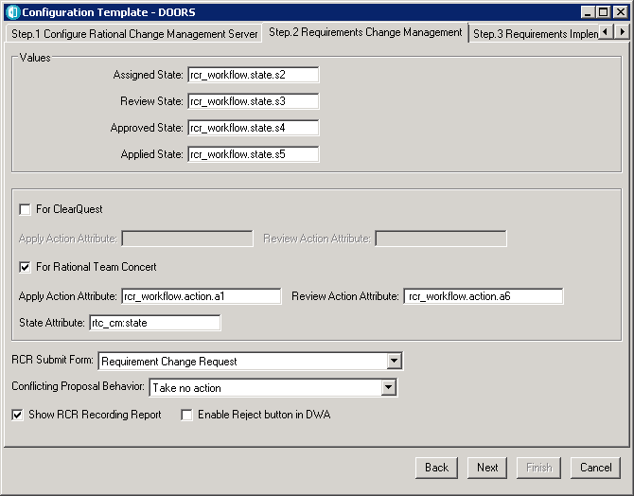

**Note:** You must use the internal workflow state and action identifiers, not the names that are displayed in RTC. You can find internal workflow state identifiers here:

https://rtc:9443/ccm/oslc/workflows/project area ID/states/Workflow

Internal workflow action identifiers here:

https://rtc:9443/ccm/oslc/workflows/project area ID/actions/Workflow:

In this example, the URLs are(works in Chrome):

<https://bsd-pc1528497:9443/ccm/oslc/workflows/_KS9yUKY9Eeanc4moPDbR5w/states/rcr_workflow>

[https://bsd-pc1528497:9443/ccm/oslc/workflows/_KS9yUKY9Eeanc4moPDbR5w/actions/rcr_workflow](https://bhttps://bsd-pc1528497:9443/ccm/oslc/workflows/_KS9yUKY9Eeanc4moPDbR5w/actions/rcr_workflow)

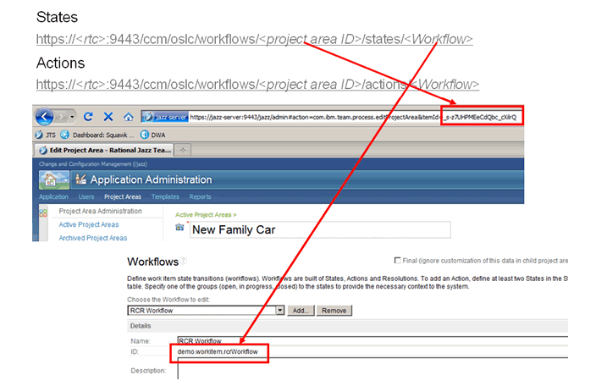

When you open these URLs, an XML file is displayed listing the state identifiers and the action identifiers, for example:

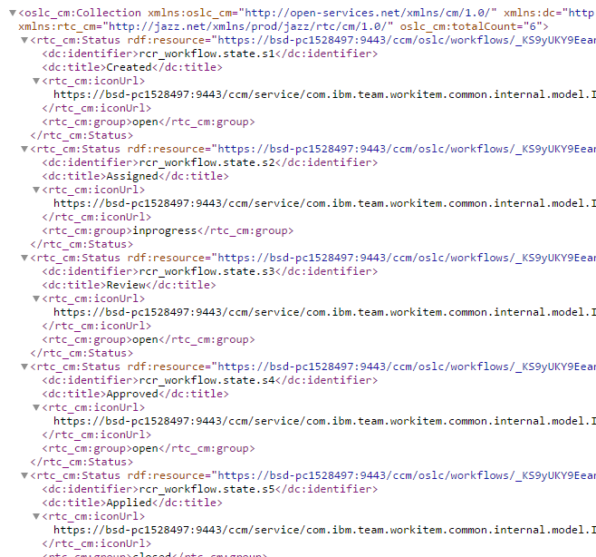

In this example, the state is **Assigned**, which is denoted by the **dc:title**, and the state identifier is **RCR Workflow.state.s2**, which is denoted by the **dc:identifier**.

1. In **Assigned State**, enter the state identifier **RCR Workflow.state.s2**.
2. In **Review State**, enter the state identifier **RCR Workflow.state.s3**.
3. In **Approved State**, enter the state identifier **RCR Workflow.state.s4**.
4. In **Applied State**, enter the state identifier **RCR Workflow.state.s5**.
5. Select **For Rational Team Concert**.
6. In **Apply Action Attribute**, enter the action identifier **RCR Workflow.action.a2**.
7. In **Review Action Attribute**, enter the action identifier **RCR Workflow.action.a3**.
8. In **State Attribute**, enter **rtc_cm:state**.
9. In **RCR Submit Form**, select **Requirement Change Request**.
10. In **Conflicting Proposal Behavior**, select **Take no action**.
11. Clear **Show RCR Recording Report** and **Enable Reject button in DWA**.

**Requirement Change Management tab**

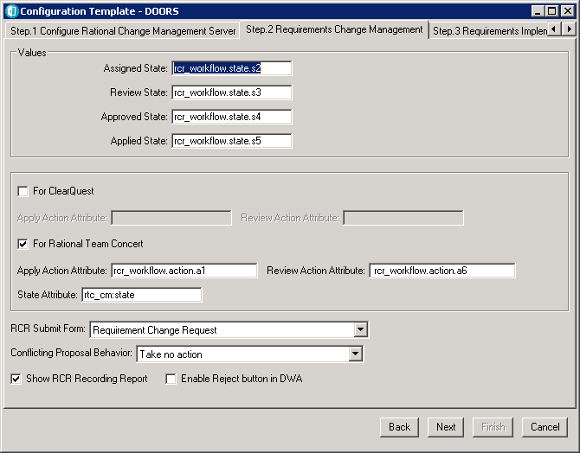

1. Click **Next**. **Step 3** of the **Configuration Template wizard** is displayed.
2. Select **Plan Item** in **Use Submit Form** and **Plan Item** in **Use Add Form**. Plan Item is one of the Change Management Binding Settings in RTC Project Area, and is bound to Story.

**Requirement Implementation tab**

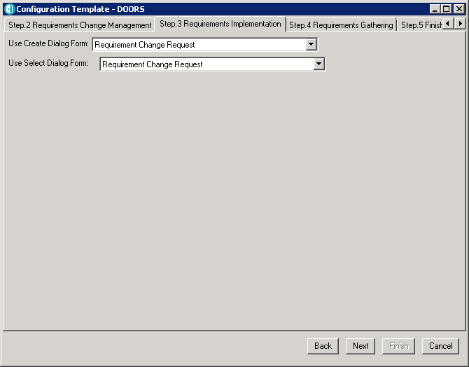

1. Click **Next**, Enter the query details for gathering requirements from Rational Team Concert.
2. **Tip:** The query format should be rtc_cm:state in ["2"], where "2" represents the *Inprogress* state of a work item in Rational Team Concert.
3. Click **Next**.
4. Verify the summary details, and then click **Finish**.

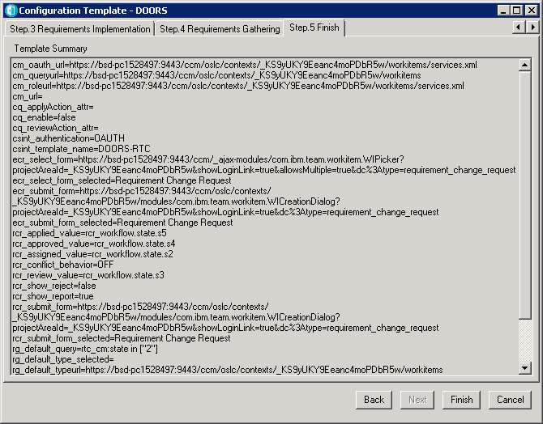

**Requirements Gathering tab**

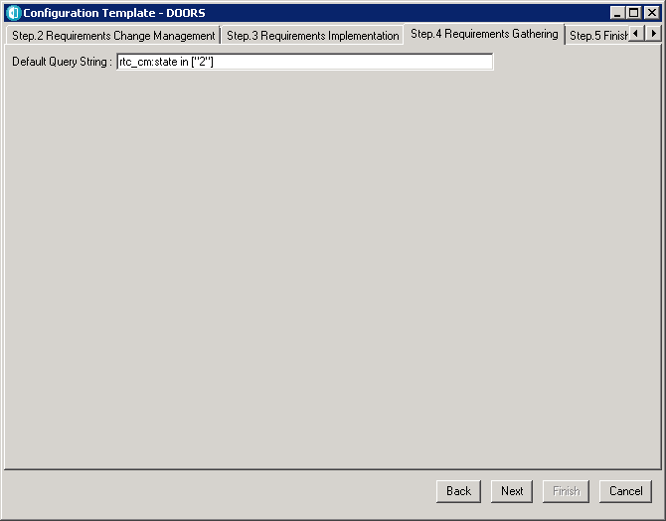

**Set up the module configuration in Rational DOORS**

To use the integration, you must set up the module in Rational DOORS to use the configuration template.

Set up the module to use both **Requirements Change Requests** and **Implementation Requests**.

**To configure a module:**

1. Open Rational DOORS.
2. Open the module you want to work with, and click **Change Management > Configure Module**.
3. Select the RTC configuration template. This defines the project in RTC that you will connect to.
4. Set **Integration Status** to **ON**.
5. Select **Enable Requirements Change Management** to use Requirements Change Requests. The related fields can be edited. Leave them selected:

* **Create RCR Attrs View** creates a view in the module that lists all the Requirements Change Requests that have been implemented against individual objects.
* **Manage External Links** and **Manage Internal DOORS Links** manage traceability. Rational DOORS has both internal and external links, and they can be managed independently.

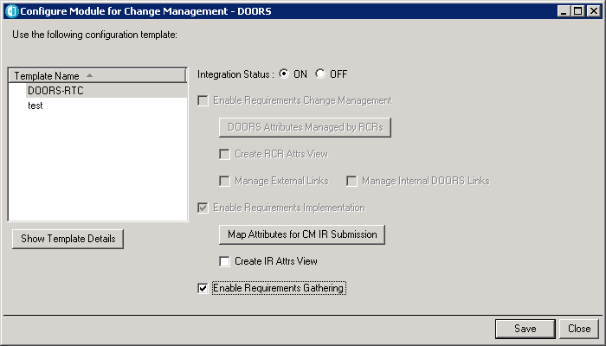

**Note:** If you want to use the Implementation Request feature where requirements are sent to RTC for developers to use, then you must consider managing external links. An Implementation Request creates an external link to the work item in RTC. If you are managing external links, you must create an Implementation Request as part of a Requirements Change Request. If you are not managing external links, you can open the module for unmanaged changes and raise the Implementation Request.

1. Select **DOORS Attributes Managed by RCRs**, choose the attributes you want to manage, and click **Apply**. By default, the integration manages the changes to Object Heading and Object Text. If you want, you can select other attributes (for example, custom attributes such as Priority, Cost, and so on).
2. Select **Enable Requirements Implementation** to use Implementation Requests. The related fields can be edited:

* Select **Create IR Attrs View** to create a view in the module that lists all the Implementation Requests that have been implemented against individual objects.
* Clear **Enable Requirements Gathering**.

1. Select **Map Attributes for CM IR Submission**, choose the attributes you want to map, and click **Apply**.

The Rational DOORS attributes are listed. Associate the attributes with RTC values by entering the RTC values in the **CM Attribute** column. By default, Object Heading is mapped to title, and Object Text to description. Custom attribute values must match the available values in RTC. Rational DOORS does not automatically check the associations; make sure you check them manually.

**Requirements traceability**

**Gather requirements from Rational Team Concert for DOORS**

1. Start the Rational DOORS client by executing **doors.exe**.
2. Log in to DOORS as a user with Database Administrator privileges.
3. Create a formal module in DOORS, using the default template.
4. Open that module.
5. Select **Change Management > ConfigureModule**.
6. Select the configuration template for Rational Team Concert.
7. Change Integration Status to **ON**.
8. Select **Enable Requirement Gathering**, as shown in Figure 21.
9. Then click **Save**.

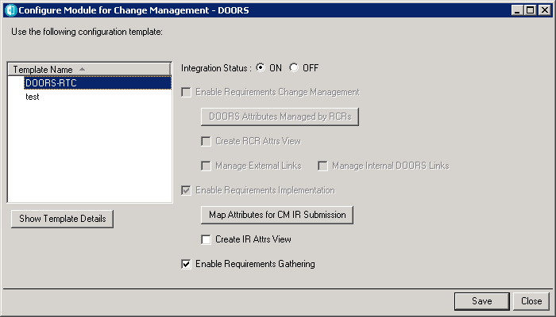

**Retrieve requirements from Rational Team Concert**

1. Select **Change Management > Retrieving Requirements for Change Management tool > Define Attribute Mapping**.
2. Select **DOORS Attribute**, and click Edit.
3. Choose the CM Attribute, and then click Close,

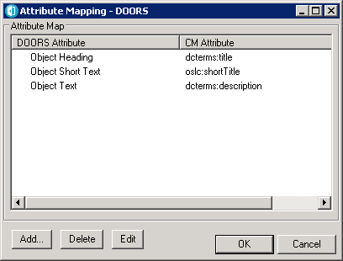

4. Click **OK** after the attribute mapping is finished.

5. Select **Change Management > Retrieving Requirements for Change Management tool > Get Requirements**.

6. Verify the Query String, and then click **Import**.

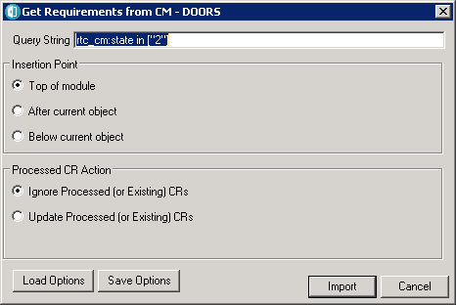

1. After the requirements are imported to the DOORS formal module, from Rational Team Concert, click to Save the module.

Note: You can also add requirements to the module manually.

**Manage a Requirements Change Request Enable Requirements Change Request on the module**

1. Start DOORS client, by executing doors.exe.

2. Log in to DOORS as user with Database Administrator privileges.

3. Create a formal module in DOORS using the default template.

4. Open the formal module.

5. Click **Change Management > Configure Module**.

6. Select the configuration template for Rational Team Concert.

7. Set Integration Status to ON.

8. Select the Requirements Change Request option

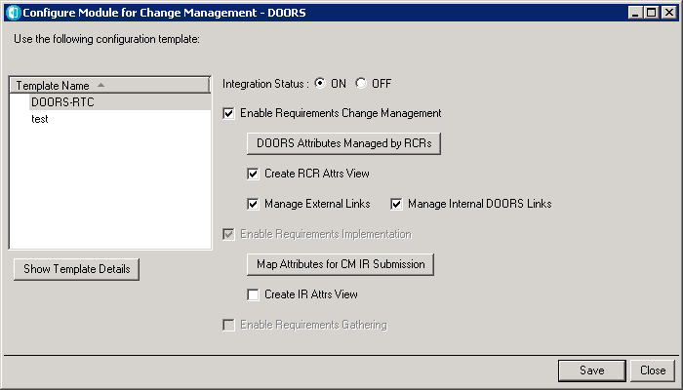

1. Click Save.

**Submit the default Requirement Change Request**

* 1. Open the formal module in DOORS in read-only.
  2. Click **Change Management > Requirements Change Request > Submit**.
  3. Enter details in the Submit Request dialog window

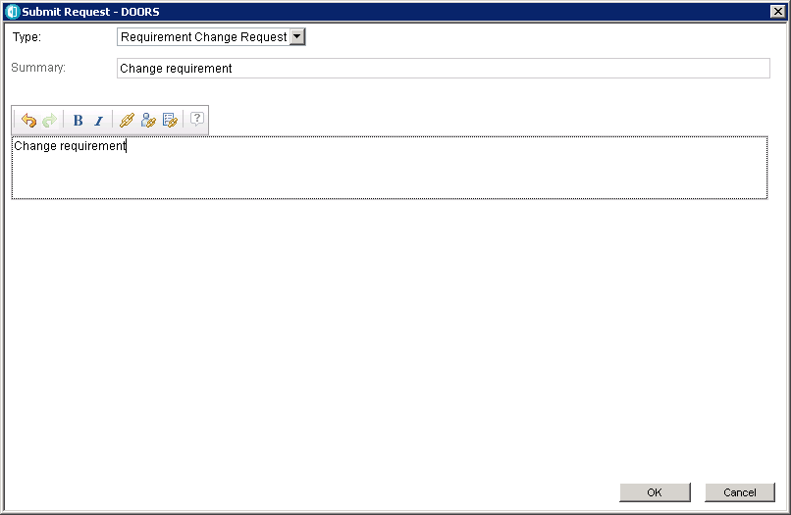

* 1. Click OK to submit the Requirement Change Request.
  2. Enter the user ID and password for Rational Team Concert login and click Log In.
  3. View the Requirements Change request details submitted.

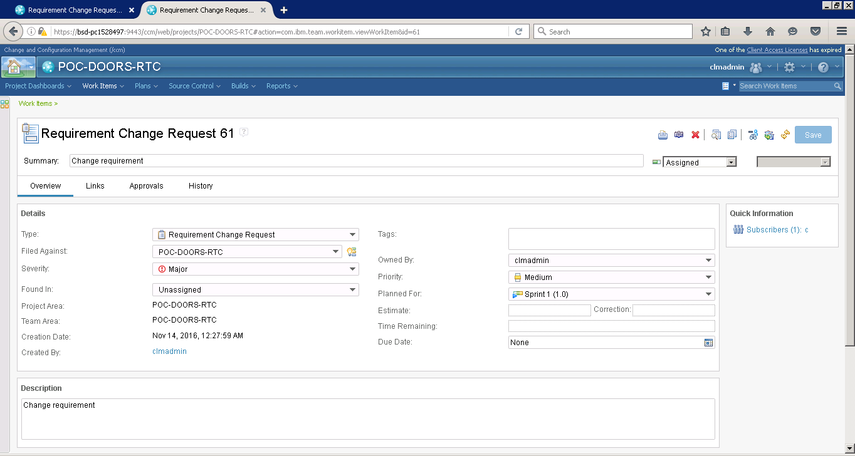

7. Click Logout to exit from Rational Team Concert, and close the browser.

8. Invoke the formal module in DOORS, and select **Change Management > Requirements Change Request > Select Default**.

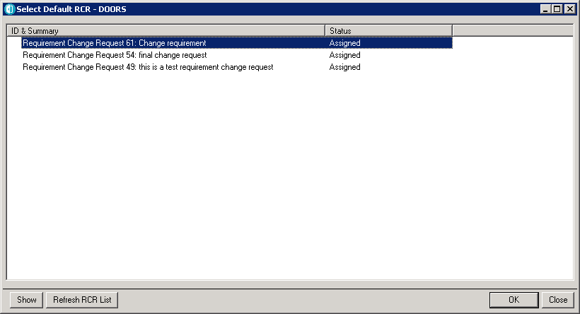

1. Select the Requirements Change Request, and click **OK**.
2. Modify the object details in the formal module, and then click **Save**.

The Recording Report view displays the changes made to the module.

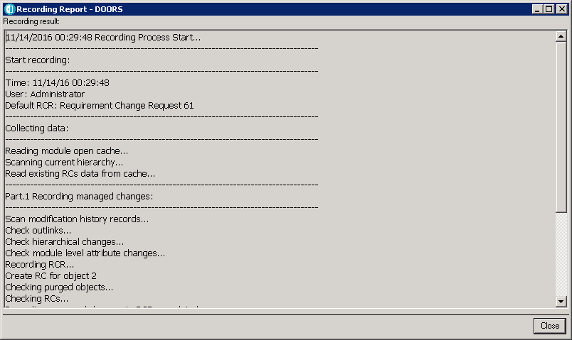

**View changes made to the module**

1. Open the formal module in DOORS in Exclusive edit mode.
2. Select **Change Management > Requirements Change Request > Show** for this module.
3. Select the Requirement Change Request, and click **Show**.
4. Enter the Rational Team Concert user ID and password of, and click **Log In**.
5. Click the **Links** tab. This displays the DOORS Web Access link details under the Tracks Requirements section

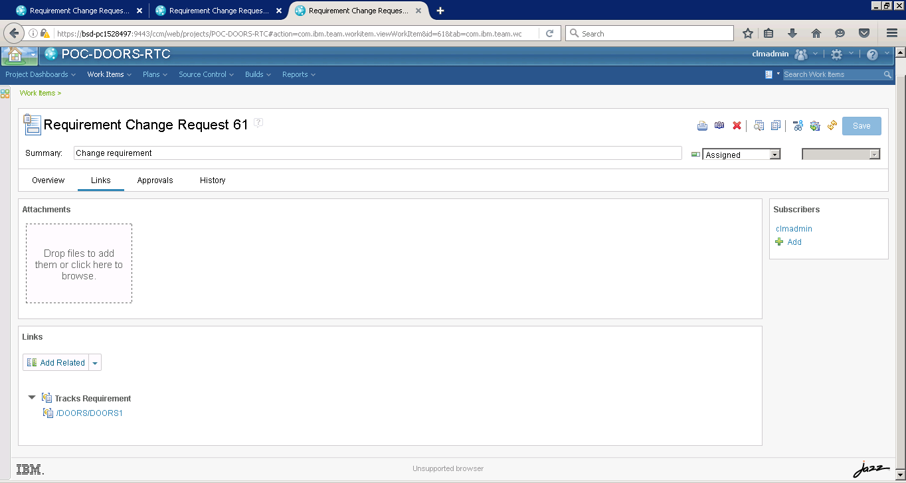

Clicking on the link in the Tracks Requirements section redirects you to DOORS Web Access

1. Enter the username and password details for DOORS Web Access, and then click **Login**.
2. When you get a prompt, install the ActiveX Control.

After login, the list of Requirement Changes made to the module and the details are displayed.

the Requirement Change details contain the DOORS URL for the respective object

Note: Clicking the DOORS URL link redirects you to the respective object in the formal module.

8. Click the **Reject** to reject the changes made to the requirement.

9. Click **OK** in the confirmation dialog, to confirm rejecting the changes made.

10. Click **OK** in the DOORSRCMCONTROL dialog window.

The requirement modification gets rejected

**Send the Requirement Change Request to the Review state**

* 1. Open the formal module in DOORS in **Exclusive Edit**.
  2. Complete the changes made to the formal module.
  3. Click **Change Management > Requirements Change Request > Send RCR to Review** to send the Requirement Change Request to review state

You can click **Confirm** to send the RCR for review or click **Cancel** to cancel the review process.

* 1. Send RCR to review.
  2. Launch IE or Firefox.
  3. Type this URL in the address bar to start Rational Team Concert: <https://QualifyingServername:9443/ccm/>

**Note**: Accept the secured connection certification.

* 1. Enter the user ID and password, and click **Log In**.
  2. Enter the Requirements Change Request ID in the search dialog, and view the defect details.
  3. Click the **Approval** tab and then the **New: Approval** link to add the approver of the Requirements Change Request.
  4. Enter the Approver name and due date.
  5. Click **Save** and log out of Rational Team Concert.
  6. As an approver of the Requirements Change Request, approve the changes.
  7. Transition the Requirement Change Request to the **Resolve** state.

**Apply changes made to the module**

* 1. Open the formal module of DOORS in Read-Only mode.
  2. Select **Change Management > Requirements Change Request > Apply**.
  3. When the Apply Requirements Change Request dialog displays the resolved Requirement Change Request, select the Requirement Change Request, and click **Apply** to apply the changes made to the requirements in the formal module

Changes made to the module will then get applied.

**Manage an Implementation Requirements Request**

1. Start the Rational DOORS client by executing doors.exe.
2. Log in to DOORS as a user with Database Administrator privileges.
3. Open the formal module in Read-Only mode.
4. Click **Change Management > Configure Module**.
5. Select the configuration template for Rational Team Concert.
6. Select the **Enable Requirements Implementation** option

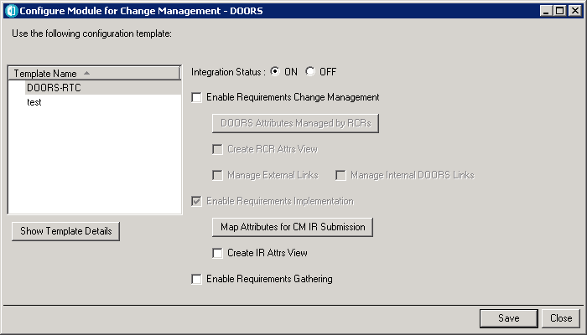

1. Click **Save**.
2. Select the requirements that need to be implemented, right-click, and select Implementation **Request > Submit**.
3. Enter details in the Submit Request dialog window
4. Click OK to submit the Implementation Request.

Select the requirement in DOORS and view the link. An external link gets created for the Implementation Request submitted.

1. Select the requirements that need to be implemented, right-click, and select **Implementation Request > Add**. This allows you to add additional Implementation Requests to the requirement, if any.

**Transition the Implementation Request to the Resolved state**

1. Launch IE or Firefox.
2. Type this URL in the address bar to start Rational Team Concert: <https://QualifyingServername:9443/ccm/>

**Note**: Accept the secured connection certification.

1. Enter user ID and password, and then click **Log In**.
2. Enter the Implementation Request (Defect ID) in the search dialog, and view the defect details.
3. As a **Developer**, transition the defect to the **Resolved** state, after the requirement change gets implemented.
4. Log out of Rational Team Concert.

**Review the Show Activity Report**

1. Open the formal module of DOORS in Read-only mode.
2. Select the **Change Management > Show Activity Report** option.
3. Review the detailed requirement details, along with the Implementation Requirement details.

**Create Links for requirements in DOORS to Change requests in RTC for traceability:**

Open the module which you want to work on.

Right click on the object and create a link.

To create a link to the work item in RTC right click on the object **Link>New Tracked By>Project Area in RTC** (You will find the project area which you have set in configuration template).

You can link to the existing artifact or create a new artifact and then link.

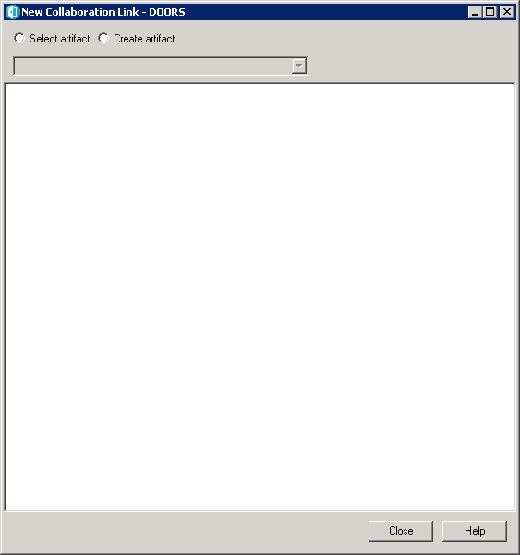

You can search for an artifact by searching for a keyword or a work item number or by using a query.

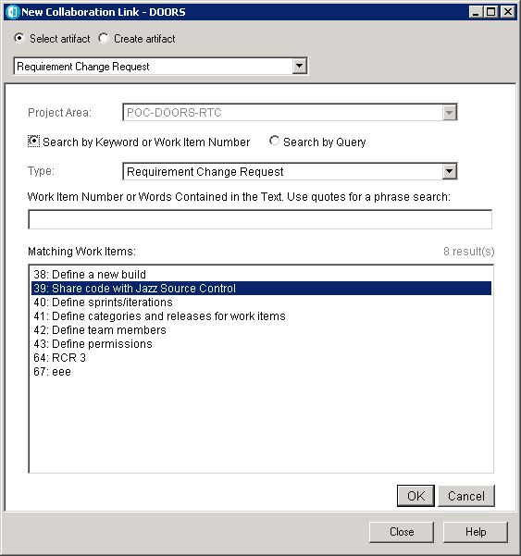

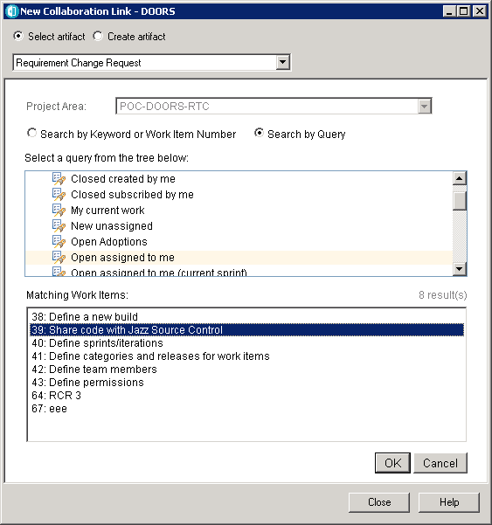

Select the artifact and click **OK**.

You can find that the link has been created.

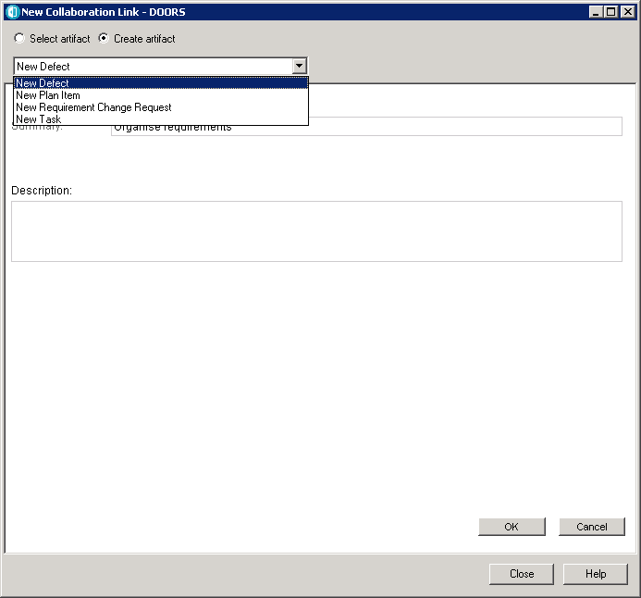

If you are creating a new artifact, you can select the type of artifact, provide the details and click OK.

You will be redirected to RTC login page. Enter the credentials, check the details and log out.

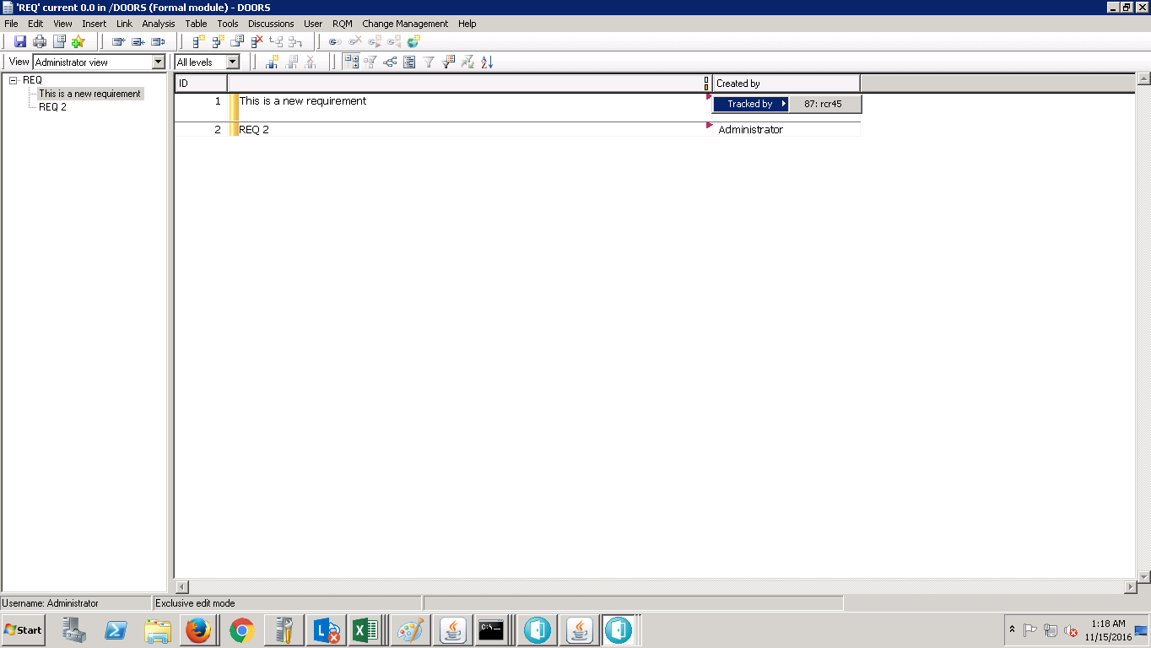

You can find the links created in DOORS. Right click on the **red flag >tracked by>work item** to view the artifact in RTC or you can just hover the work item and the details will be displayed.

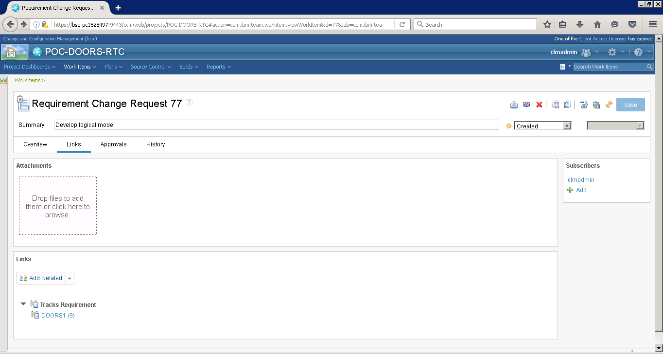

The link to the requirement is displayed in the links section.

Clicking on the link leads to the DWA login page.

You can login and view the linked requirements.

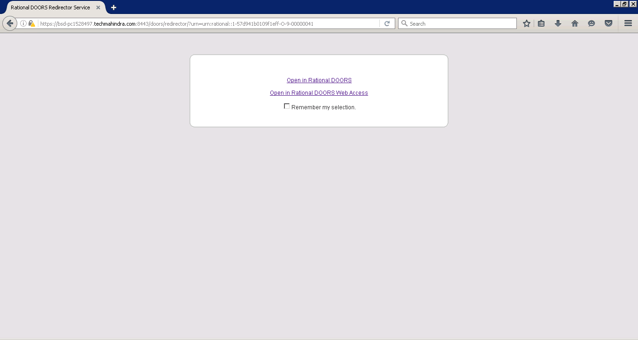

**Creating links from DWA:**

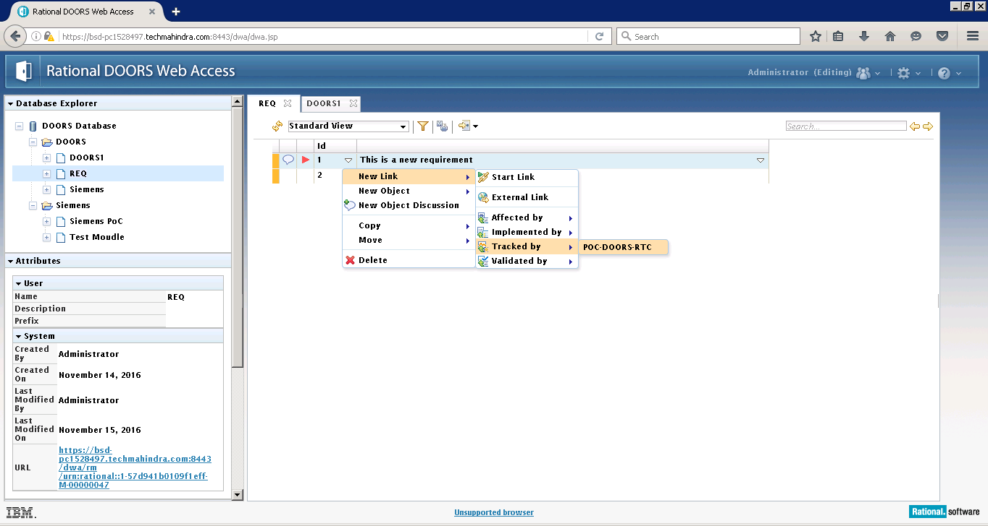

Click on the white down arrow in the Id column **New Link>Tracked By>Project Area Name.**

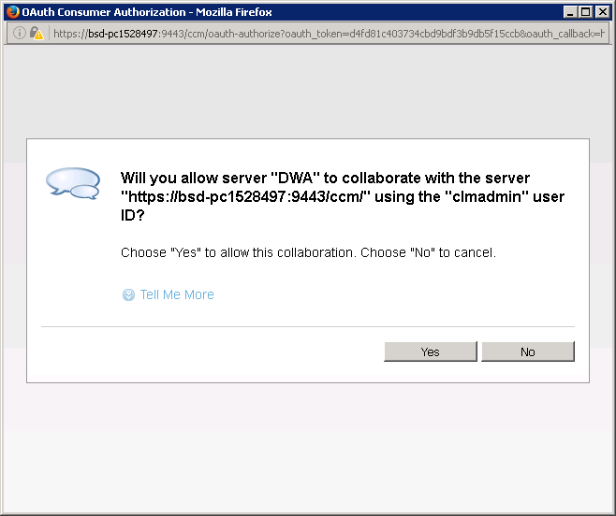

Click **Yes.**

You will be redirected to RTC Login Page. Provide the credentials and Login.

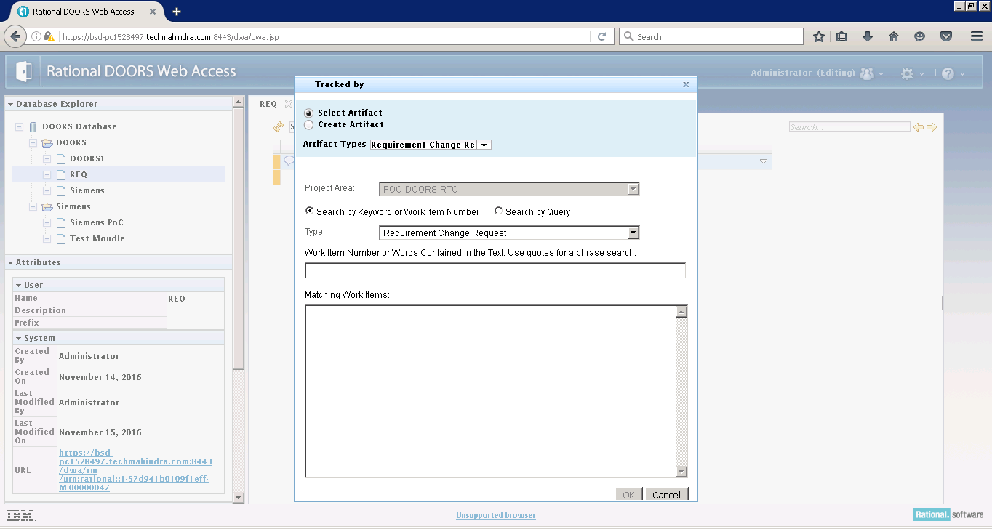

A window appears to create a link to the artifacts in RTC.

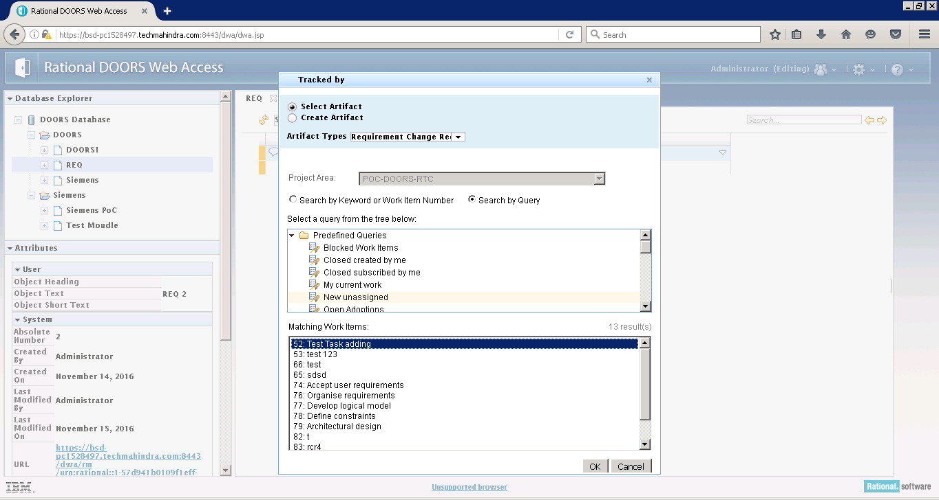

Use query or search by Id to select the artifact and click **OK**.

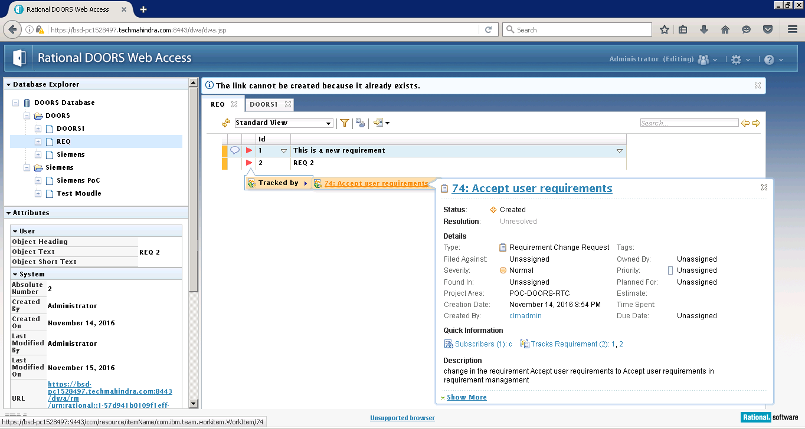

A link to the artifact in RTC is created in DWA. Click on the red flag to view the link details.

**Creating Views:**

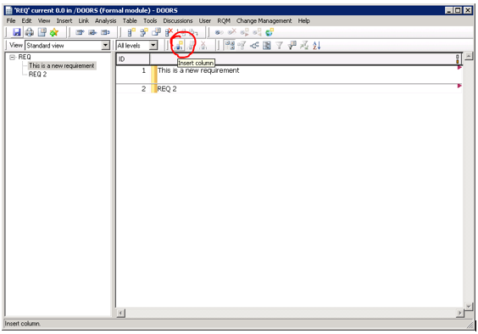

Views can be created such that only the required columns are visible.

Click on insert column icon and select the contents as shown in figure.

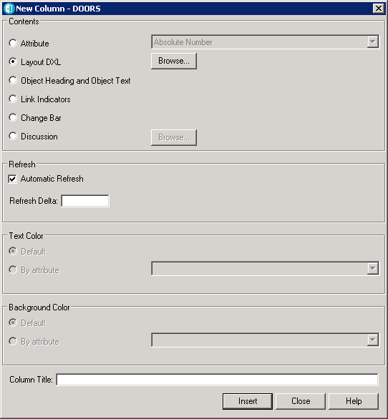

Provide the title of column that you want to create and click Insert.

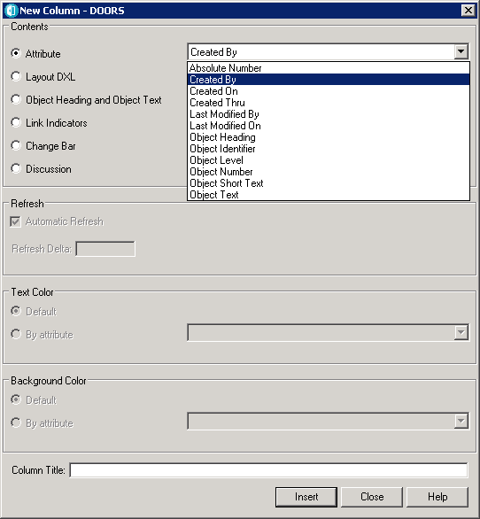

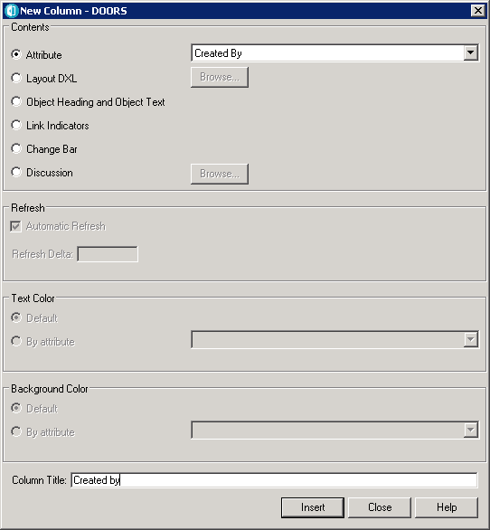

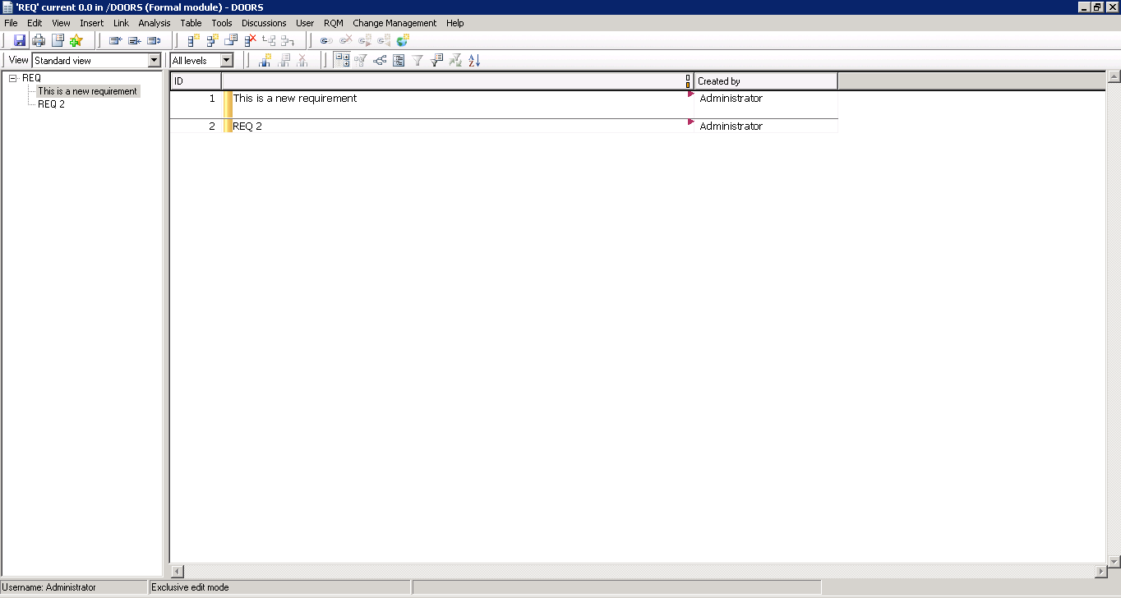

The new column will be inserted.

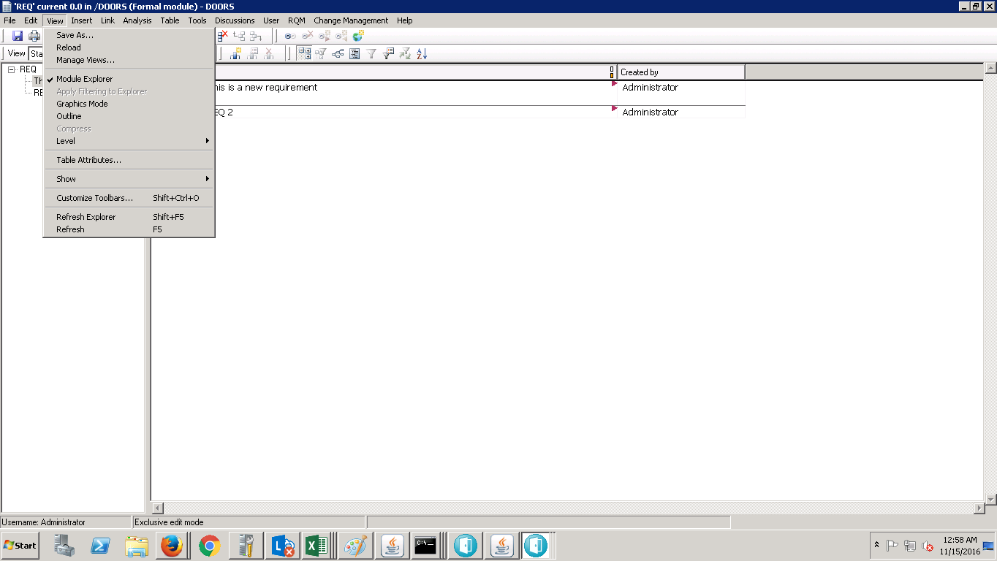

After inserting all the required columns,

Goto **View>Save As**

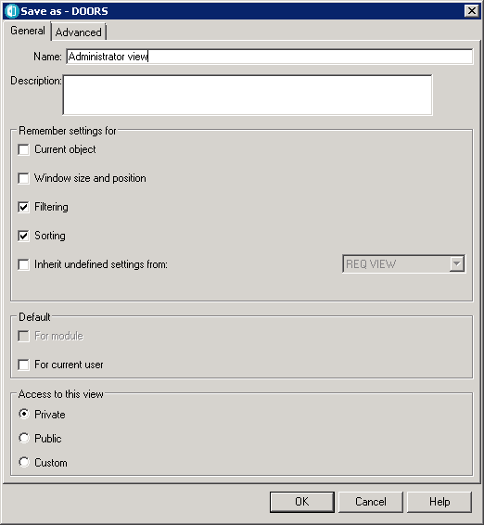

Provide the name and click OK.

You can toggle between the views by selecting the view you want.

